Receiving services through OCP2!
OCP2 (One Community Partnership 2) is a Broward youth system of care initiative implemented through Broward Behavioral Health Coalition that helps young people and their families during their transition into adulthood. OCP2 focuses on youth 14-21 who have emotional and mental health challenges, and who may also have experiences with trauma and/or substance use issues, by supporting their recovery, resiliency and wellness.

evidence-based SERVICES

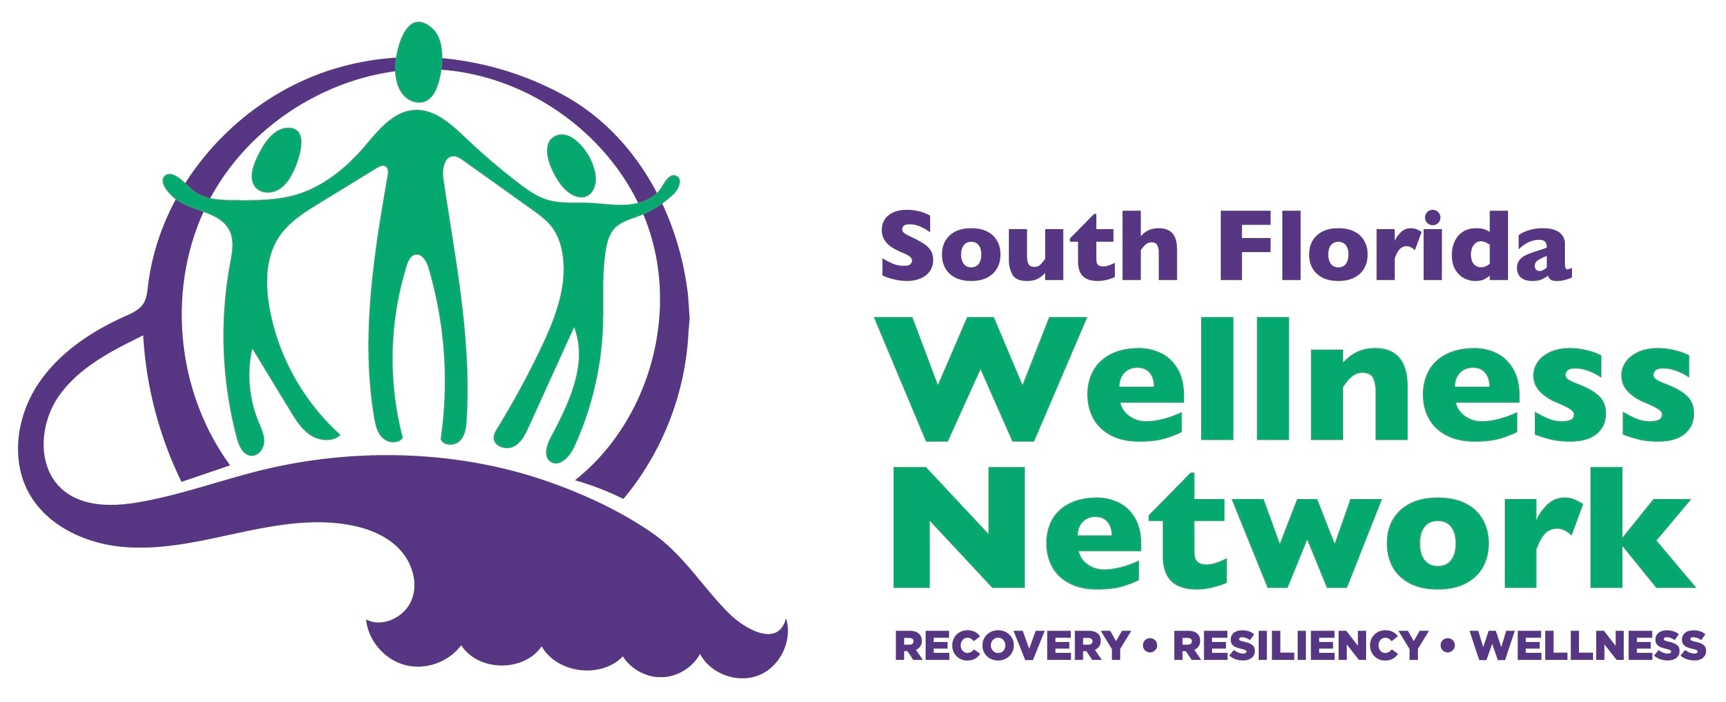
FAMILIES AND YOUTH ADVOCACY AND SUPPORT
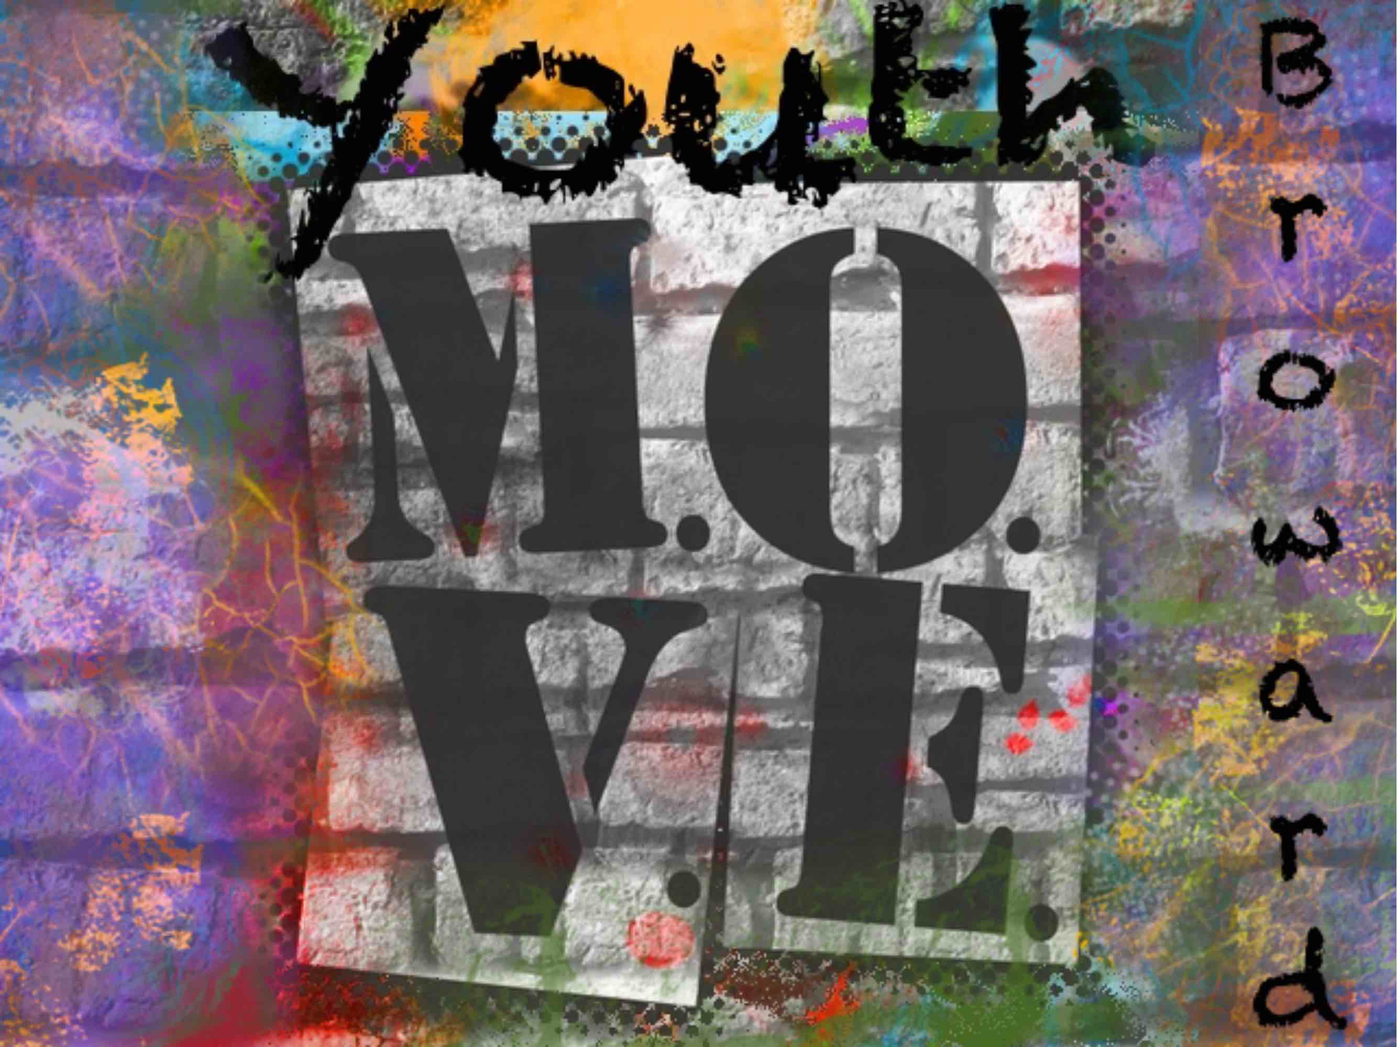
Peer-operated organization focused on individual empowerment towards the hope of recovery. Offers adult and youth peer support, community engagement and recovery trainings www.SFWN.org

- Youth M.O.V.E. Broward educates, advocates and empowers youth 14-29 through creative projects, workshops, trainings and job opportunities.
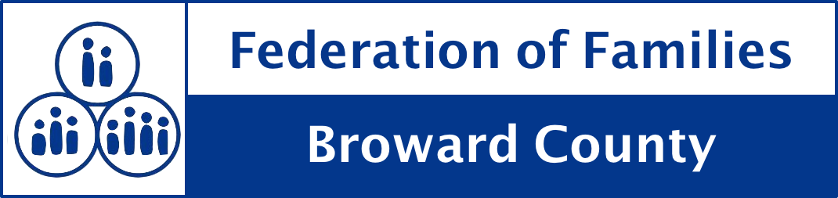
- Federation of Families of Broward County empowers families whose children and/or youth have or are at risk of behavioral, emotional, mental health, and/or substance abuse challenges through education & advocacy.

REFERRAL / ENROLLMENT
YOUR ROLE! | Referral- when a youth is referred for services | OUR ROLE! | Enrollment- when the youth and family agree to be part of the grant Evaluation
- Determine eligibility using Referral Form  - Disuses TIP and other services with youth  - Complete the form and gather required documentation, including release of information  - Send to Tiffany Smith, OCP2 Clinical Integration Coordinator at tsmith@bbhcflorida.org  - Tiffany will send disposition form with determination  - If meets criteria, referral is sent to provider who will engage the youth with services immediately |  | - Once youth is engaged in services, the agency’s TIP Transition Facilitator will discuss the purpose of the evaluation to give feedback about services  - Youth will choose whether or not to be contacted about the Evaluation  - An OCP2 Peer Evaluator will contact the youth to discuss benefits of participating  - If the youth/family agree, they are “enrolled” into the evaluation so their feedback can improve our system of care

BBHC-funded TIP PROVIDERS

Agency | Contact Person | Phone | Emails
Gulfcoast Jewish and Family Services | Tania Hamilton | 954-829-7453 | thamilton@gcjfcs.org
Camelot Community Care Inc. | Bobby Crume | 954-825-1111 | bcrume@camelotcommunitycare.org
Henderson Behavioral Health | Debbie Toro | 954-649-8027 | dtoro@hendersonbh.org
Smith Community Mental Health | Liat Kazes | 954-321-2296 | Liat.kazes@smithcmh.com
South Florida Wellness Network | Susan Nyamora | 954-533-0585 | susan@sfwn.org
SunServe | Mandi Hawke | 954-764-5150, x. 202 | mhawke@sunserve.org

OCP2 STAFF INFORMATION:
Role | Contact Person | Phone | Emails
Project Director | Emery Cowan | 954-560-1151 (c) | ecowan@bbhcflorida.org
Clinical Integration Coordinator: referrals and linkage to services | Tiffany Smith | 954-560-1206 (c) | tsmith@bbhcflorida.org
Recovery Support Navigator: employment, education, housing linkage | Celia Hall | 954-873-3238 (c) | chall@bbhcflorida.org
Peer Evaluator: engages in evaluation feedback | Alfonso Ruiz | 954-622-8121 | aruiz@bbhcflorida.org

www.OCP2.org
954-622-8121
Referral Form
www.ocp2.org/services/referrals/

